***The Harbor Ridge Homeowner***

**A Publication of the Harbor Ridge Homeowners Association SUMMER 2011**

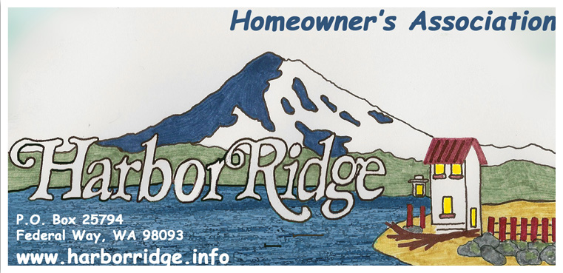

**What IS happening in your community?**

**Neighborhood Block Party, August 28, 4 p.m. to 7 p.m.:** Save Sunday, August 28, for a neighborhood block party at Resurrection Lutheran Church! This party is open to neighbors from Harbor Ridge, Harbor Ridge Estates and members of Resurrection Lutheran Church. We will have something for everyone: fun games for the kids, plus some surprises; for the adults, some local politicians will stop by, a master gardener will be present to answer your questions and much more; for everyone, hot dogs, soda, water and ice cream. If possible, please bring a side dish or snack to share and join us for a few hours of fun and meeting some of your neighbors. Please watch our web site [www.harborridge.info/](http://www.harborridge.info/) and click on “projects” for more information.

**Resurrection Lutheran Church:** 4301 Browns Pt. Blvd. NE, 253-927-3301

**Super Saturday, September 17, 2011, starting at 8 a.m. - not just any Saturday!** Come join us for the fun!

Free Breakfast, Blood Drive, Food Drive, Four-Legged Food Drive, Master Gardener Clinic, Pet Adoptions and much more! Super Saturdays are the third Saturday, every two months.

**Vacation Bible School, August 9-12, 2:00-5:00 pm & August 14, 9:45 am to 12:30 pm – Calling all kids:** Preschool through 6th grade are invited to attend:**"Pandamania: Where God is Wild About You!"** *It's going to be a bamboo blast!*The wildest Vacation Bible School you’ve ever seen! You’ll explore amazing Bible adventures, sample yummy snacks, make and take cool crafts, and so much more. We can’t wait to see you there! To register stop by or call the church office at (927-3301). Resurrection Lutheran Church, 4301 Browns Point Blvd. NE, Tacoma, WA 98422

**Neighborhood Awareness:** There are a few homes for sale or in foreclosure in our area. Besides keeping an eye on your neighborhood, it is a good idea to be aware of the homes that are empty. If you notice anything unusual, please report it via an email through our website ([www.harborridge.info](http://www.harborridge.info)) or call one of the Board members. We had an empty home that a family of raccoons had occupied, it was reported and the appropriate people were notified to take care of the problem.

**City Ordinance:** Were you aware that a City of Tacoma code protects the quality of life of neighborhoods from urban blight, by providing standards for the appearance and condition of properties? Some nuisances referred to in the new code, enforced in cooperation with the Tacoma CARES program:

* Deteriorated fencing or structures
* Littered, trash-covered, or overgrown or unkempt vegetation of any type and grasses over one foot in height
* Improper parking or storage of vehicles on single-family residential lots that impedes the use of yard area for light, air-circulation, recreation, and landscaping

When complaints against a property are reported by calling 591-5001, they are investigated. Failure on the part of the property owner to correct the situation will result in monetary civil penalties. In part to expedite the cleanup of private property, the City may then also accomplish clean up of properties that fall within these public nuisance categories, and bill the property owner. For more information, refer to [www.cityoftacoma.org/safeandclean](http://www.cityoftacoma.org/safeandclean).

**Considering Re-roofing Soon?**

Homeowners in our community with shake roofs either already have, or soon will be facing the roof replacement issue. For those whom this will affect your Architectural Control Committee (ACC) provides some choices.

Roofs are a major architectural element in setting the tone, in a physical sense, for a home and for a community. That was reflected in the Architectural Guidelines established by the Harbor Ridge Plat developer. Roofs in our community originally were either wood (shakes), with a relatively short life, or concrete tiles, with a considerably longer life.

Shake roofs usually were installed over intermittent wooden strips, to save costs. This is referred to as skip sheathing. The simplest and least expensive re-roofing alternative is to replace existing shakes with new shakes. However, finding good quality shakes can be difficult. Regular roof maintenance is almost mandatory, roof life will again be limited, and insurance cost is higher than with other roof materials because of the fire hazard associated with wood.

ACC approved roof materials, in addition to shakes, that can be used with the same roof support structure you currently have, although full sheathing will likely be required, are:

1. An estate quality laminate composite shingle. The requirement is a quality product with at least a 40-year warrantee. Since the cost of installation will be very little more for better shingles than for a lower grade shingle, it makes sense to assure that you spend the incremental amount for the material cost to assure you are installing a good product.

2. Light-weight concrete tile. The only one we are aware of at this time is Monier Premium Duralite 2000.

3. Metal products produced in sheet stock made to simulate shingles or tile. The ones that have been approved to this point are: Metal Works “Aston Woods’ steel, and Interlock ‘Super Aluna’ aluminum.

These options in general are more expensive, up front, than redoing shakes. We expect that new developments in materials and business competition will result in other acceptable options in the future.

Based on discussions with the City of Tacoma Building Department personnel, it is our understanding that no building permit is required either for redoing shakes or for the above-listed alternatives. A structural inspection and a building permit are required if you choose to upgrade your roof structure for the conventional, heavy weight tile. For questions with regard to permits, call the Building Department at (253) 591-5004.

We strongly urge you to call the Washington State Department of Labor and Industries at (253) 596-3800 to evaluate a roofing contractor’s licensing and bonding before you agree to the work. This can be vital in the event of subsequent contract disagreements.

The ACC can assist you in making an informed decision about re-roofing your home. We would be pleased to review the material you are considering. If you have questions, or wish to have the ACC consider materials other than those approved and described in this article, please don’t hesitate to contact the ACC through our web site.